Solicitation of Bid for Timber

October 28, 2024

You are invited to bid on timber located as follows: 11 acres located in Section 28, Township 37 North, Range 5 West, Crawford County, Missouri. The land and timber is owned by St. John UCC. To view the sale contact forester Jason Deschu at (573) 291-7906.

Description: All trees to be cut have been measured and marked with a spot of orange paint.

The estimated gross, merchantable volume is as follows

|  |  |
| --- | --- |
| Species | International ¼ Scale |
| White Oaks | 34,997 |
| Red Oaks | 3,589 |
| Other | 36 |
| Total | **38,622** |

Sale has very good access with very short skids and good road access, only 10 miles to Steelville, or 17 miles to Cuba.

Buyer will have until May 1, 2025 to harvest timber.

This is a “lump sum” sale for the estimated volume only. Although reasonable care has been exercised in estimating volume, no guarantee is made or implied that this volume is recoverable. The sale is for the designated trees and no adjustment will be made for either overrun or underrun. The bidder should determine the number of logs present and bid accordingly. Selection of a winning bid may not be based solely on highest bidder.

Bid Intructions: Mail completed bid to:

Triangle D Forestry LLC

41441 Maries Road 630

Dixon, MO 65459

Bids should be mailed to be received on or before 11 a.m. Monday December 2nd , 2024. Bid opening will be at 4:00 p.m. Monday December 2nd, 2024 at the sale property. Hand carried sealed bids may be submitted before 4:00 p.m. on Monday December 2nd,

If your bid is accepted, contract must be signed and payment made in full within ten working days from date of notification of bid acceptance.

The owner reserves the right to Reject Any and All Bids.

|  |  |  |  |  |  |  |  |  |  |  |  |  |  |  |  |  |  |
| --- | --- | --- | --- | --- | --- | --- | --- | --- | --- | --- | --- | --- | --- | --- | --- | --- | --- |
| **Sum - volume** |  |  |  |  |  |  |  |  |  |  |  |  |  |  |  |  |  |
| *Species* | *10* | *11* | *12* | *13* | *14* | *15* | *16* | *17* | *18* | *19* | *20* | *21* | *22* | *24* | *26* | *28* | **Total Result** |
| White oak | 143 | 894 | 1413 | 3140 | 4843 | 3294 | 5834 | 1986 | 4581 | 1304 | 4033 | 1240 | 722 | 350 | 521 | 487 | **34787** |
| Black oak |  |  |  |  | 237 | 93 | 143 |  | 373 | 518 | 702 | 326 | 580 |  |  |  | **2972** |
| Red oak |  | 46 |  |  | 51 | 248 | 107 | 164 |  |  |  |  |  |  |  |  | **617** |
| Chinkapin oak |  |  |  |  |  |  |  |  |  | 210 |  |  |  |  |  |  | **210** |
| Maple |  |  | 36 |  |  |  |  |  |  |  |  |  |  |  |  |  | **36** |
| **Total Result** | **143** | **940** | **1449** | **3140** | **5131** | **3636** | **6085** | **2151** | **4954** | **2032** | **4735** | **1565** | **1302** | **350** | **521** | **487** | **38622** |

Estimate of volume by diameter at breast height and species. Int. ¼ scale

|  |  |  |  |  |  |  |  |  |  |  |  |  |  |  |  |  |  |
| --- | --- | --- | --- | --- | --- | --- | --- | --- | --- | --- | --- | --- | --- | --- | --- | --- | --- |
| **Count - volume** | **Data** |  |  |  |  |  |  |  |  |  |  |  |  |  |  |  |  |
| *Species* | *10* | *11* | *12* | *13* | *14* | *15* | *16* | *17* | *18* | *19* | *20* | *21* | *22* | *24* | *26* | *28* | **Total Result** |
| Maple |  |  | 1 |  |  |  |  |  |  |  |  |  |  |  |  |  | **1** |
| White oak | 5 | 19 | 23 | 35 | 43 | 24 | 36 | 10 | 21 | 5 | 14 | 4 | 2 | 1 | 1 | 1 | **244** |
| Red oak |  | 1 |  |  | 1 | 2 | 1 | 1 |  |  |  |  |  |  |  |  | **6** |
| Black oak |  |  |  |  | 2 | 1 | 1 |  | 2 | 2 | 3 | 1 | 2 |  |  |  | **14** |
| Chinkapin pak |  |  |  |  |  |  |  |  |  | 1 |  |  |  |  |  |  | **1** |
| **Total Result** | **5** | **20** | **24** | **35** | **46** | **27** | **38** | **11** | **23** | **8** | **17** | **5** | **4** | **1** | **1** | **1** | **266** |

Count of trees by diameter at breast height and species.

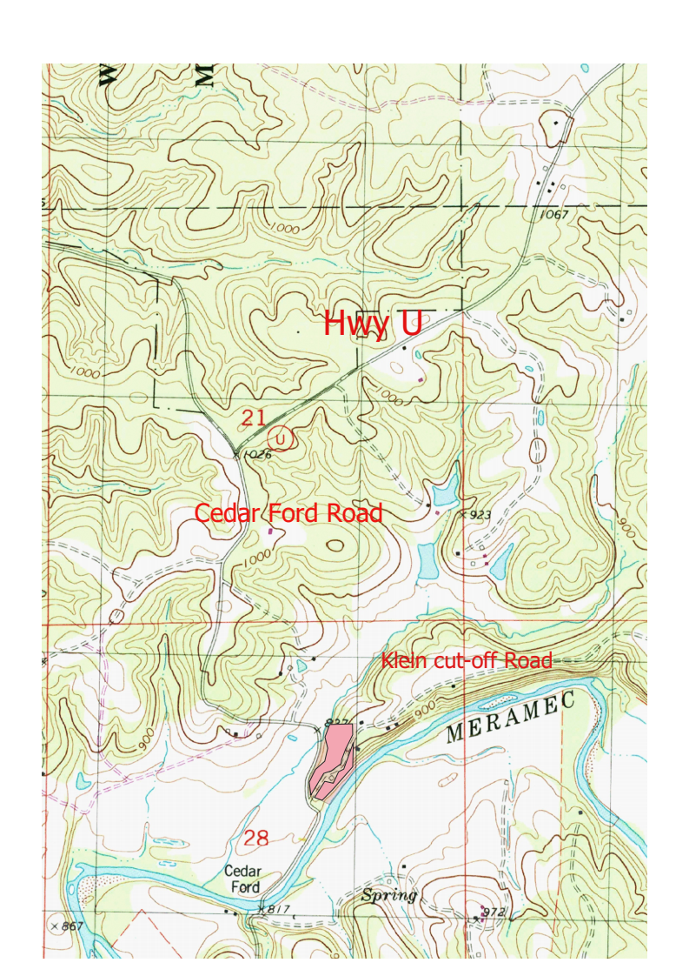

St. John UCC Sale Map

St. John UCC Timber Sale Bid

Name of Bidder: ______________________________________

Address of Bidder: _____________________________________

_____________________________________

______________________________________

Telephone: ______________________________

Total Amount of Bid: _________________________________________________

($ _______. ___)

(Lump Sum Bids Only)

Signature: ___________________________ Date: ___________________